Project Design Phase-II
Technology Stack (Architecture & Stack)

Date | 04 October 2026
Team ID | SWTID-2026-6519
Project Name | Script-Controlled ACL – Restrict Record Access Based on Field Value
Maximum Marks | 4 Marks

Technical Architecture:
The Deliverable shall include the architectural diagram as below and the information as per the table1 & table 2
Architecture: ServiceNow script-controlled ACL for record-level security
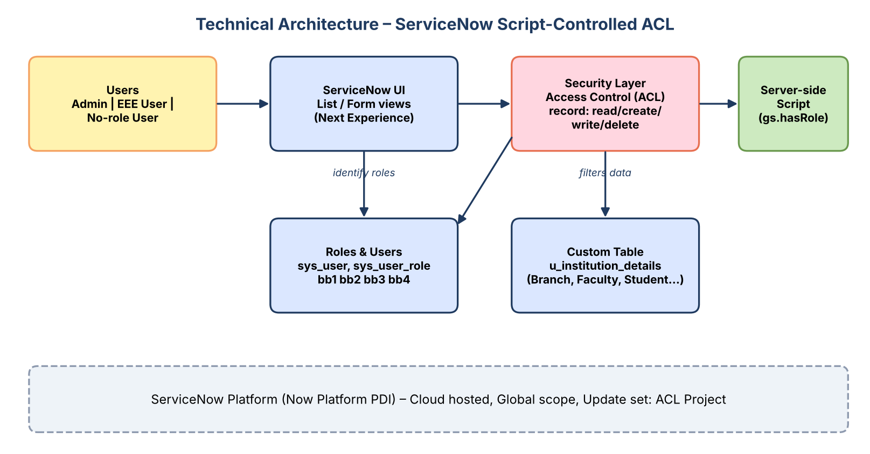

Table-1 : Components & Technologies:
S.No | Component | Description | Technology
- 1. | User Interface | ServiceNow Next Experience UI – list and form views used by admin and branch users | ServiceNow platform UI (Application Navigator, list/form), Service Portal
- 2. | Application Logic-1 | Record ACLs per operation (read, create, write, delete) on u_institution_details | ServiceNow Access Control (ACL), roles bb1–bb4
- 3. | Application Logic-2 | Advanced ACL script: admin / bb1 → true, else false | Server-side JavaScript (gs.hasRole)
- 4. | Application Logic-3 | Data condition 'Branch is EEE' applied on the read ACL | ACL data condition (filter builder)
- 5. | Database | Custom table u_institution_details (7 fields); users and roles in sys_user / sys_user_role | ServiceNow relational database (Now Platform)
- 6. | Cloud Database | Hosted and managed by the ServiceNow instance | ServiceNow cloud (Personal Developer Instance)
- 7. | File Storage | Not required – no attachments are used | N/A
- 8. | External API-1 | Not required | N/A
- 9. | External API-2 | Not required | N/A
- 10. | Machine Learning Model | Not applicable | N/A
- 11. | Infrastructure (Server / Cloud) | Application deployed on the ServiceNow cloud instance  Local Server Configuration: none (browser only)  Cloud Server Configuration: ServiceNow PDI, Global scope, update set 'ACL Project' | ServiceNow cloud

Table-2: Application Characteristics:
S.No | Characteristics | Description | Technology
- 1. | Open-Source Frameworks | None – built on the ServiceNow low-code platform | ServiceNow Now Platform
- 2. | Security Implementations | Role-based ACLs, field-value data condition, scripted ACL, admin override, security_admin elevation to edit ACLs | ACL, IAM roles, security_admin
- 3. | Scalable Architecture | Same ACL pattern re-used for other tables/branches; multi-instance cloud platform | ServiceNow cloud (multi-tier)
- 4. | Availability | Platform-managed high availability of the ServiceNow cloud | ServiceNow cloud
- 5. | Performance | Lightweight role checks; no database queries inside the ACL script; filtering happens in the query | Optimised ACL evaluation (role → condition → script)

References:
https://c4model.com/
https://developer.ibm.com/patterns/online-order-processing-system-during-pandemic/
https://www.ibm.com/cloud/architecture
https://aws.amazon.com/architecture
https://medium.com/the-internal-startup/how-to-draw-useful-technical-architecture-diagrams-2d20c9fda90d

